Name: ________________________________________________________________ Date: _________________________

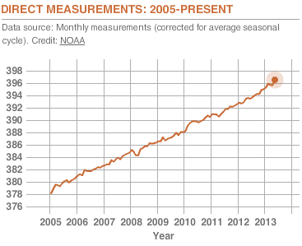
- What was the carbon dioxide
concentration in 2006?
- Draw a line of best fit for this graph.
- What is the equation for your line of best
fit?
- Predict the carbon dioxide concentration
for 2025.

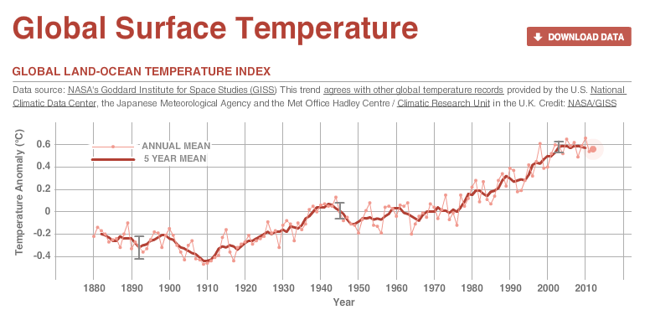

- What was the global surface temperature in 1960?
- Draw a line of best fit for this graph.
- What is the equation for your line of best fit?
- Predict the global surface temperature for 2025.

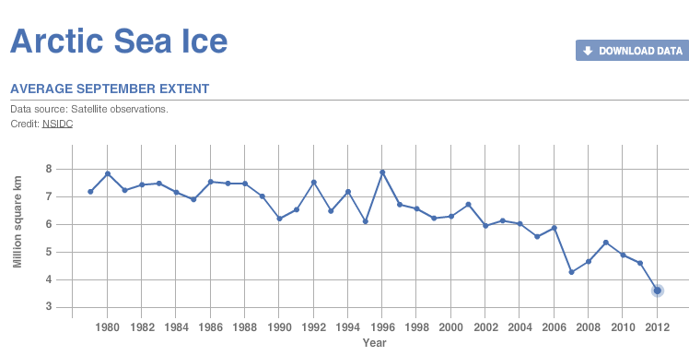

- How much artic sea ice was there in 1998?
- Draw a line of best fit for this graph.
- What is the equation for your line of best fit?
- Predict the amount of artic sea ice for 2025.

