CLIMATE GRAPH FACILITATION AND KEY

Facilitation:

Hand the worksheet to students, or allow them to view the document on their laptops. If they are using hard copies, rulers (or some other straight edge) need to be provided. If they are using their laptops, they can use the Shapes tool on Microsoft Word to create the line of best fit. This activity is a straightforward activity. Questions that might help guide students who are stuck include:
- How do you draw the line of best fit?
- What do you need for the equation of a line? Do you have all that information? How can you find it?
- What if you are given two points on a line?
- What if you are given the slope and the y-intercept?
- How can you use your equation to make predictions about the future?
- What can you do so that you aren’t using such large numbers to represent years?

Following the activity, take some time to debrief and discuss the graphs from the activity. Some debriefing questions include:
- What do these graphs mean?
- What does climate have to do with anything we’ve discussed so far?
- Is there a connection between biofuels and climate change?
- Is there a connection between food supple and climate change?
Name: ________________________________________________________________ Date: _________________

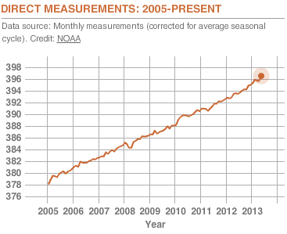
- What was the carbon dioxide
concentration in 2006? 381 parts per
million
- Draw a line of best fit for this graph.
- What is the equation for your line of best
fit? $y=2x+368$, x is the number of
years after 2000
- Predict the carbon dioxide concentration
for 2025. 418 parts per million

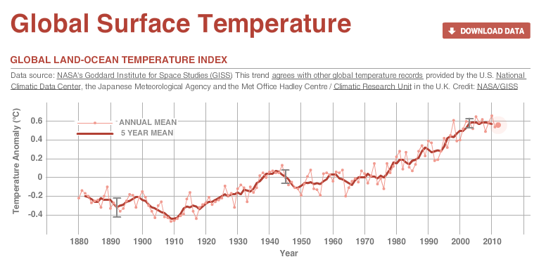

- What was the global surface temperature in 1960? 0$°$ Celsius
- Draw a line of best fit for this graph.
- What is the equation for your line of best fit? $y=.008x-1.12$, x is the number of years after 1800
- Predict the global surface temperature for 2025. 0.68$°$ Celsius

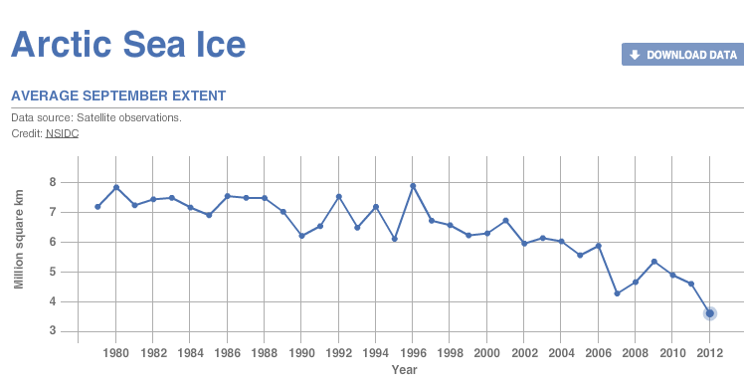

- How much artic sea ice was there in 1998? 6.5 million km²
- Draw a line of best fit for this graph.
- What is the equation for your line of best fit? $y=-.083x+14.3$, x is the number of years after 1900
- Predict the amount of artic sea ice for 2025. 0 million km² (answer will be negative, and you can’t have a negative amount of land)

